# Workforce Management (WFM)

The practice of ensuring that an organization has the right number of staff in the right place at the right time. It involves forecasting the amount of work that needs to be done, scheduling staff to meet that demand, and adjusting staffing levels as needed.

## WFM Cycle

1. Demand Predictions.
2. Capacity Plans.
3. Schedule Plans.

## WFM Reports

1. Adherence (Time and attendance).
2. Absence (Shrinkage).
3. Performance (Monitor and Provide Feedback).

## WFM Tools

1. WFM NOW.
2. NICE IEX.

## Real-time Management (RTM)

Tracking and monitoring key performance metrics, such as call volumes, service levels, and agent activities, in real-time to ensure operational efficiency and productivity.

# Excel Functions

## Math

### SUM

Adds up the values in a range of cells.

=SUM({number1},{number2},{number3},…)

=SUM({starting_cell_in_range}:{ending_cell_in_range})

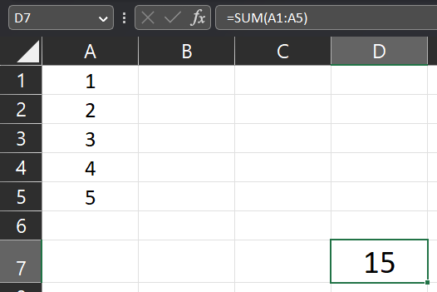

Ex: =SUM(A1:A5)

* This formula will calculate the sum of the values in cells A1 to A5, resulting in 15.

@@@@@@@

### SUMIF

Adds up the values in a range of cells that meet one specific criteria.

=SUMIF({criteria_range}, {condition}, {sum_ range})

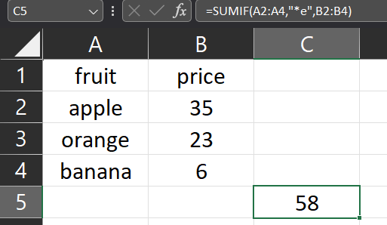

Ex: =SUMIF(A2:A4,"*e",B2:B4)

* This formula will calculate the sum of the values in cells A2 to A4 that ends with “e”, resulting in 35+23=58.

@@@@@@@

### **SUMIFS**

Adds up the values in a range of cells that meet specific criteria.

=SUMIFS({sum_ range}, {criteria_range1}, {criteria1}, {criteria_range2}, {criteria2}, ...)

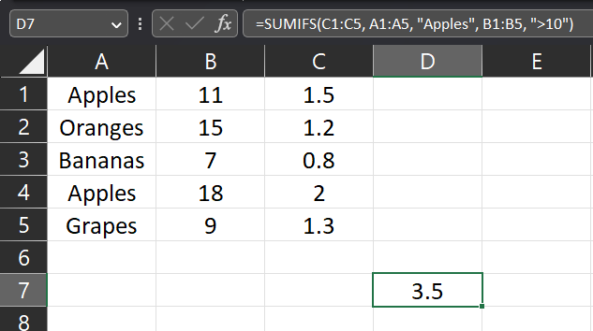

Ex: =SUMIFS(C1:C5, A1:A5, "Apples", B1:B5, ">10")

* This formula will calculate the sum of the prices (in column C) for Apples (in column A) with quantities greater than 10 (in column B), resulting in the total price of $3.5.

Ex: =SUMIFS(A2:A3,B2:B3,C2,D2:D3,E2)

* This formula will calculate the sum of A2:A3 only when B2:B3 equals C2 (5) and D2:D3 has “n” in it, resulting in 1.

@@@@@@@

### ABS

Returns the absolute value of a number.

=ABS({number/cell})

Ex: =ABS(A1)

* This formula will calculate the absolute value of A1, resulting in 34.

@@@@@@@

### MAX

Returns the largest value in a set of numbers.

=MAX({number1, number2, number3, …} / {range})

Ex: =MAX(A1:A6)

* This formula will return the largest value in A1:A6, resulting in 75.

@@@@@@@

### MIN

Returns the smallest value in a set of numbers.

=MIN({number1, number2, number3, …} / {range})

Ex: =MIN(A1:A6)

* This formula will return the smallest value in A1:A6, resulting in 7.

@@@@@@@

### ROUND

Rounds a number to a specified number of decimal places.

=ROUND({number/cell}, {number_of_digits})

Ex: =ROUND(A1,2)

* This formula will round the value in A1 to 2 decimal spaces, resulting in 1.33.

@@@@@@@

## Logical

### **IF**

Conducts a logical test and returns one value if the condition is true, and another value if false.

=IF({condition}, {if_true}, {if_false})

Ex: =IF(B2>=65, "Pass", "Fail")

* This formula will return the first value (Pass) if the condition is True or the second value (Fail) if the condition is False.

@@@@@@@

### **IFS**

Performs multiple logical tests and returns the appropriate value based on the first true condition.

=IFS({condition1}, {if_true}, {condition2}, {if_true}, TRUE, {else_what})

Ex: =IFS(B2>1000, "Good", B2 >= 800, "Average", TRUE, "Poor")

* This formula will return the corresponding value to the true condition and if all conditions failed it will return (Poor).

@@@@@@@

### **AND**

returns TRUE if all the conditions specified are true, otherwise it returns FALSE.

Ex: =AND(5=5,3<>9,TRUE)

@@@@@@@

### OR

returns TRUE if any of the conditions specified are true, otherwise it returns FALSE.

Ex: =OR(2=5,9<>9,FALSE)

@@@@@@@

### NOT

returns the opposite of a logical value. If the logical value is TRUE, it returns FALSE, and vice versa.

=NOT(A1=5)

@@@@@@@

## Statistical

### Count

Counts the number of cells that contain numeric values in a range. It excludes text, errors, and empty cells.

=COUNT({count_range})

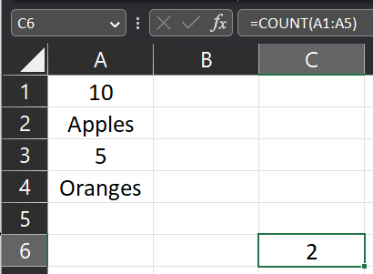

Ex: =COUNT(A1:A5)

* This formula will count the number of cells within the given range (A1:A5) that contain numeric values only resulting in the count of 2.

@@@@@@@

### **Counta**

Counts the number of cells that are not empty in a range.

=COUNTA({count_range})

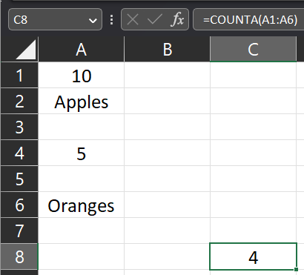

Ex: =COUNTA(A1:A6)

* This formula will count the number of cells within the given range (A1:A6) that are not empty resulting in the count of 4.

@@@@@@@

### **COUNTIF**

Counts the number of cells that meet A specific criteria.

Ex: =COUNTIF(A1:A7,"*e")

* This formula will count the number of cells that ends with “e”, resulting in the count of 1.

@@@@@@@

### **COUNTIFS**

Counts the number of cells that meet multiple specified criteria.

=COUNTIFS({count_range1}, {condition1}, {count_range2}, {condition2}, …)

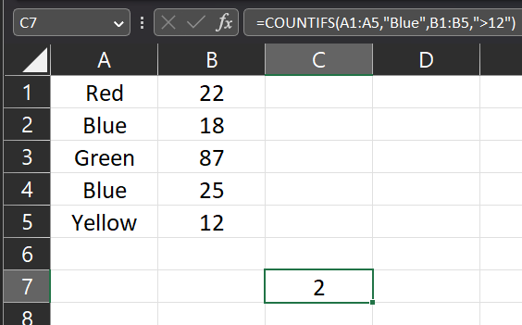

Ex: =COUNTIFS(A1:A5,"Blue",B1:B5,">12")

* This formula will count the number of instances where "Blue" appear in column A and the corresponding quantity in column B is greater than 12, resulting in the count of 2.

@@@@@@@

### **COUNTBLANK**

counts the number of empty cells within a specified range.

Ex: =COUNTBLANK(A1:A7)

* This formula will count the number of empty cells within the specified range A1:A7, resulting in the count of 3.

@@@@@@@

### **AVERAGE**

Returns the average of a range of numbers.

Ex: =AVERAGE(A1:A4)

* This formula will calculate the average of the given range A1:A4, resulting in 2.

@@@@@@@

### MAX

Returns the largest value in a range of numbers.

Ex: =MAX(A1:A4)

* This formula will return the largest value in the given range A1:A4, resulting in 5.

@@@@@@@

### MIN

Returns the smallest value in a range of numbers.

Ex: =MIN(A1:A4)

* This formula will return the smallest value in the given range A1:A4, resulting in 2.

@@@@@@@

## **Lookup**

### **XLOOKUP**

Finds a value in a range and returns the corresponding value from the other range.

=XLOOKUP(

{look_for_this_value},

{in_this_range},

{return_the_corresponding_value_from_here},

{what_if_not_found},

{match_mode},

{search_mode}

)

Match Mode:

* 0: (Default) exact match
* -1: The next smallest item if no exact match.
* 1: The next largest item if no exact match.
* 2: Wildcard (anything matches given value)

Search Mode:

* 1: (Default) first value found.
* -1: Last value found.

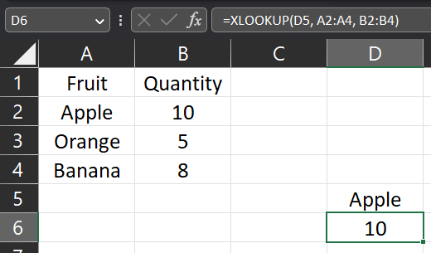

Ex: =XLOOKUP(C1, A2:A4, B2:B4)

* This formula will search for value in D5 (Apple) in the first given range (A2:A4) and returns its corresponding value in the second given range (B2:B4), resulting in number 10.

@@@@@@@

## **Text**

‘{number} : sets the number as a text

* You can use it as a number by getting its value: =value({A1})

### CONCATENATE

Joins multiple text strings into one.

Ex: =CONCATENATE(A1," ",B1," ",C1)

* This formula will concatenate all the given values into one text value.

@@@@@@@

### TEXT

Used to convert a value to a specific text format based on a provided format code.

=TEXT({text}, {format})

**Formats**:

* Number Formatting:

=TEXT(1234.5678, "#,##0.00") // Returns "1,234.57"

=TEXT(0.1234, "0.00%") // Returns "12.34%"

=TEXT(42, "000") // Returns "042"

* Date Formatting:

=TEXT(DATE(2022, 9, 15), "dd-mm-yyyy") // Returns "15-09-2022"

=TEXT(NOW(), "mmm yyyy") // Returns "Sep 2022"

* Time Formatting:

=TEXT(TIME(9, 30, 0), "hh:mm:ss") // Returns "09:30:00"

=TEXT(NOW(), "h:mm AM/PM") // Returns "6:30 PM"

* Custom Formatting:

=TEXT(A1, "0.00") // Returns a number with two decimal places.

=TEXT(B1, "dd/mmm/yyyy") // Returns the format "dd/mmm/yyyy".

=TEXT("Hello World", ">>@<<") // Returns ">>Hello World<<"

@@@@@@@

### LEN

Returns the length of a text string.

=LEN({cell/text})

Ex: =LEN(A1)

This formula will return the length of a given text string.

@@@@@@@

### RIGHT

Returns a number of characters starting from the right

=RIGHT({text}, {number_of_characters})

@@@@@@@

### LEFT

Returns a number of characters starting from the left

=LEFT({text}, {number_of_characters})

@@@@@@@

### MID

Returns a number of characters starting from a given starting position

=MID({text}, {starting_position}, {number_of_characters})

@@@@@@@

### SUBSTITUTE

Replaces specific text within a string with new text.

=SUBSTITUTE({text}, {remove_this}, {replace_with_this})

Ex: =SUBSTITUTE(A1,"s","uss")

This formula will replace the given text “s” with new characters “uss”

@@@@@@@

## Date

### Date

Returns a date

=DATE({year}, {month}, {day})

@@@@@@@

### DAY

Returns a day

=DAY({date})

@@@@@@@

### MONTH

Returns a month

=MONTH({date})

@@@@@@@

### YEAR

Returns a year

=YEAR({date})

@@@@@@@

### EDATE

Roll-forward given date

=EDATE({start_date}, {number_of_months})

@@@@@@@

### EOMONTH

Returns the end of a given date

=EOMONTH({start_date}, {number_of_months})

@@@@@@@

### TODAY

Returns the current date.

@@@@@@@

### NOW

Returns the current date and time.

# Excel tips

## Auto re-number column regarding the filter

=SUBTOTAL(103, $B$2:B2)+ ROWS($B$2:B2) - COUNTA($B$2:B2)

* Subtotal calculates all cells containing text
* Rows returns all rows count
* CountA returns all rows containing text

**This way we add blank cells to the total**

@@@@@@@

## Autofit cells

1. Right click sheet
2. View code
3. A screenshot of a computer

   Description automatically generated
4. Worksheet
5. 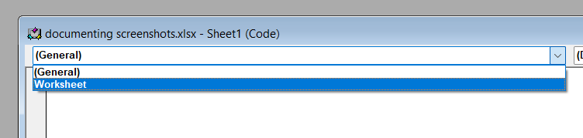
6. Cells.EntireColumn.AutoFit
7. A screenshot of a computer

   Description automatically generated
8. Close from X
9. Done!

@@@@@@@

## Select text only to copy

1. Select range
2. Ctrl + G
3. Special
4. Constants
5. Uncheck all but text
6. Ok

@@@@@@@

# Excel Shortcuts

## Ctrl + E : Auto fill below rows

From this

To this

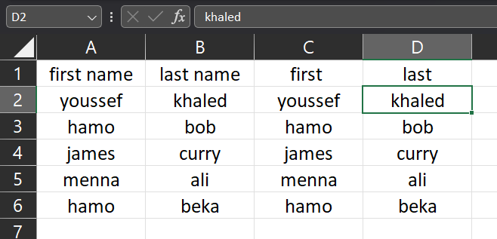

@@@@@@@

## Alt + F1 : quick chart

@@@@@@@

## Alt + = : Auto sum

From this

To this

@@@@@@@

# Resources

Requirement Traceability Matrices (RTM) | Business Analyst Interview Questions and Answers (Part 7)

<https://www.youtube.com/watch?v=omD6Wtn7kdI>

What is Workforce Management (WFM)?

<https://www.youtube.com/watch?v=Zk1rsNnmM3Q>

Chat AI

<https://nextchat.ai/chat>

How to Pass Excel Test for Employment

<https://youtu.be/DNxMgmUK2vM?si=mwG3ihJ7IEA53GQT>